Automated Emergency Power Supply Using Solar Energy with IOT-based Monitoring and Controller Mobile Application

Kurts P. Canoy1, John Philip T. Estobo2, Christian Dave M. Bate3, Jerry I. Teleron4

Surigao Del Norte State University, Philippines

*kcanoy@scct.edu.ph, jestobo@ssct.edu.ph, cbate@ssct.edu.ph*

***Abstract*—** **This study is developed to create an Automated Power Supply using Solar Energy with IOT-based monitoring and controller mobile application that mainly uses a raspberry pi as the main processor of the system to act as an alternative power supply to a facility. The researchers used a 12v 120 watts’ solar panel to gather solar energy, multiple series and paralleled lithium-ion batteries to store energy, a 20amps PWM Solar Charge Controller to charge and manage the battery system and IOT-based components to control and automate the system with dedicated mobile application. The researchers conducted an observation and research on a specific target which is the Brgy. Serna’s Barangay Hall where the system will be implemented. The researchers were able to fabricate and developed an automated emergency power supply that can provide up to 60,000mAH of energy that can be controlled and monitored via mobile application. After multiple testing conducted by the researchers, the fabrication and development of the system were found and proved to work functionally with a good maintainability as hardware parts are available locally. However, the developed system has limitation, It’s recommended that the future researchers should add features like SMS notifications, upgrade the capacity of the batteries and etc.**

***Index Terms*—Internet-of-Things, Solar Energy, Mobile App, Raspberry Pi, Embedded System**

1. **INTRODUCTION**

Solar energy, like other renewable energy sources, is a promising and readily available energy source for addressing long-term energy challenges. Because of the tremendous demand for energy and the fact that the main energy source, fossil fuel, is finite and other sources are expensive, the solar sector is constantly growing all over the world. It has become a tool for developing countries' economic position and sustaining the lives of many poor people because it is now cost effective as a result of years of rigorous research to speed up its growth. In comparison to other renewable energy sources, the solar sector would undoubtedly be the best alternative for future energy demand because it is superior in terms of availability, cost effectiveness, accessibility, capacity, and efficiency [1]. The project is all about developing and fabricating an alternative emergency power supply that mainly uses solar energy as the main source of power

The project can provide multiple useful benefits to the end-users. Since the system uses solar energy collected by the solar panel, it can greatly reduce the maintenance cost of an alternative power supply. The system also has a dedicated mobile application that makes the system user-friendly, easy to manage, control and monitor. The entire system is connected to a REST-API which makes it accessible anywhere by the end-user as long as the mobile application has an internet access. A REST API is an application programming interface (API or web API) that conforms to constraints of REST architectural style and allows for interaction with web services. REST stands for representational state transfer.   
 There are many alternative emergency power supply present today that uses solar energy to produce electricity but they are hard to manage and monitor. Many researchers claimed that Solar energy powered emergency power supply is efficient. However, they lack a user-friendly mobile application that can manage and control the system easily.

Today, having an alternative power source is deemed important and necessary, especially in our current situation where the cost for electricity is constantly increasing, power shortage and power outage is a common problem [1]. The traditional way of having an alternative power source is by using a power generator; however, it has several drawbacks like it’s harder to manage and to operate specially to people who are not familiar with mechanical things, also gasoline or diesel that is used to run a power generator cost a lot of money and is not sustainable unlike solar panels which uses free solar energy to create electricity. The main target of this project which is the Brgy. Serna’s Barangay Hall suffers a lot of power outage since our city cannot provide enough electricity for everyone, also Surigao City is prone to disaster which can temporarily cause blackouts or power outage. A lot of people suffers from the power outage because it can temporarily halt the operation of the Barangay Hall, many paper works and local governments operation is delayed as well.

Our system can provide an alternative power supply up to 60,000mAH to the Barangay Hall with zero cost. The system can be easily managed, monitored and controlled by the Barangay Hall’s personnel by the developed mobile application. They can also control and monitor the system via human interaction since the system can be operated using the physical tactile buttons present in the system and with the 2 LCD display, they can easily monitor the system’s current voltage, current and wattage.

The researchers conducted the research to make a useful project that can help the Local Government and the local community with their current problem regarding power outage in the barangay.

### Review of Related Literature

[1] proposed a system that forms an alternative power source to the government own utility power supply in Nigeria, which is unreliable and epileptic in nature. It consists of photovoltaic array, mounting frame, storage device, inverter, charge controller and wiring system. The solar power system was tested in Azure, Nigeria (Latitude 7.15oN) and the results obtained showed a good performance of the system. The output of solar power system is a function of solar radiation. The power output was high between 10.00 and 16.00 hours, which corresponds to the period of high solar radiation and coincides with the office hours. An average solar power output of 334 watts was obtained during test, while the total load of office appliances carried by the system was 290 watts.

[2] stated that Presently we are invading in a new period of modernisms i.e., Internet of Things (IoT). By using the Iota supervising solar energy can greatly enhance the performance, monitoring of the plant. It is a technique to keep track of the dust assembled on the solar panels to induce the maximum power for active utilization. The amount of output power of the solar panels depends on the radiation hit to the solar cell. All the panels are attached and the sensors are precisely connected to the central controller which supervise the panels and loads. Thus, user can view the current, voltage and sunlight.

[3] stated that to study an emergency power based on solar battery charging. Based on the electric-generation principle of solar panel, solar energy is changed into electrical energy. Through voltage conversion circuit and filter circuit, electrical energy is stored in the energy storage battery. The emergency power realizes the conversion from solar energy to electrical energy. The battery control unit has the function of PWM (Pulse-Width Modulation) charging, overcharging protection, over-discharging protection and over-current protection. It also realizes the fast and safe charging of energy storage battery. The emergency power could provide both 12V AC power for emergency equipment such as miniature PSA oxygen concentrator and 5V USB for electronic equipment (mobile phone, GPS device, rechargeable light, etc.).

[4] proposes an emergency portable solar power supply (EPSPS) by using a renewable energy source. The proposed EPSPS can be used in contingency conditions or in a rural area with non-electric power sources. The system architecture is similar to the existing photovoltaic (PV) system with a portable and user-friendly design. EPSPS comprises a solar panel, battery, charge controller, inverter, sensors, relays and Arduino Uno with Bluetooth module. The output voltage of EPSPS is 12 V and operate for 2 days without charging. The battery has required a minimum of 6 hours of charging. Based on the obtained results, the system supplied maximum up to 100 W of DC/AC power load.

### [5] proposed that Using the Internet of Things Technology for supervising solar power generation can greatly enhance the performance, monitoring and maintenance of the plant. With advancement of technologies the cost of renewable energy equipment is going down globally encouraging large scale solar plant installations. This massive scale of solar system deployment requires sophisticated systems for automation of the plant monitoring remotely using web based interfaces as majority of them are installed in inaccessible locations and thus unable to be monitored from a dedicated location. The Project is based on implementation of new cost effective methodology based on IoT to remotely monitoring a solar plant for performance evaluation. This will facilitate preventive maintenance, fault detection of the plant in addition to real time monitoring.

### To conclude, all past literature as well as studies have similar features to the present project; the use Solar Energy, the use of multiple analog sensors to get the current Voltage and currents, and IOT server for monitoring. However, no project offers mobile application which can monitor and control the device via internet connection as well as offer all the mentioned features. As a solution, the researchers decided to create a mobile application and to fill the gap between the past and present trends in IOT based Emergency power supplies.

### Conceptual Framework

The researchers used a waterfall model that describes the entire flow of the study depicted in Figure 1.

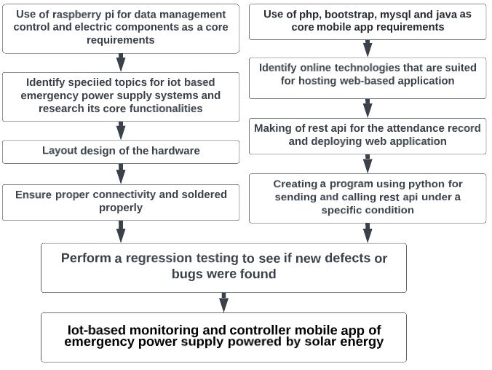

**Fig. 1. Conceptual Framework of the Study**

***Objectives***

The objective of the study is to develop an emergency power supply that uses solar panels to collect solar power, a battery system to store energy, a hardware with microcomputer to control and monitor the system, a REST API to record data from the system and to manage the control of system and a mobile application for controlling the system easily and accessible anywhere by the end user.

1. To determine the average wattage of Brgy. Serna’s Barangay hall.
2. To design and fabricate an emergency power supply powered by solar energy with IOT-based controlling and monitoring mobile application
3. To test the functionality of the charging and discharging rate of the power supply.
4. To implement the system to the Barangay Hall of Brgy. Serna, Surigao City.

**II. METHODS**

***Research Design***

The researchers used an iterative process and approach to understand its complex structure and solve problems it may encounter along the way, wherein a Plan-Do-Check-Act (PDCA) criterion is used as its model in finding a solution. After collecting relevant information and knowledge from various planning stages, the researchers assessed and converted them to factual data before postulating a pragmatic end- product. Figure 2 shows the schema of the study.

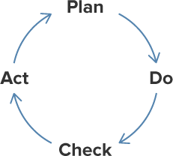

**Fig. 2. Schema of the study**

***A. Plan***

The researchers used a Raspberry Pi 4 Model B, a full- fledged tiny and affordable computer with a high-performing 64-bit quad-core processor, dual-display support at resolutions up to 4K via a pair of micro-HDMI ports, hardware video decode at up to 4Kp60, up to 4GB of RAM, dual-band 2.4/5.0 GHz wireless LAN, Bluetooth 5.0, Gigabit Ethernet, USB 3.0, and PoE capability. This will handle all operations of sending and retrieving data from the REST API and the control of system functionality. An ACS712 module is used for detecting the current of the panel and the battery, also ZMPT101b is used for detecting ac voltage, ADS-1115 also uses for converting analog signals to digital signals since the raspberry pie doesn`t have an ADC analog input. In addition to the two, a two 1.3inch OLED Display with 128x64 and I2C is used to display the solar panel information as well as the batteries information.

To collect solar energy, we make use of 12V 120watts solar panel with a voltage of 21V when open- circuit, the maximum power (Pmax(w)) is 120watts with a maximum power tolerance of ±3%, to store the electricity from the solar panels we use multiple 18650 lithium ion batteries with a total of approximately 60,000mAH, the battery output voltage is 12.7 V when fully charge and the maximum ampere is up to 30 amps. To control the charging rate of the battery system a 12 volts PWM solar charge controller will be used within the system. Figure 3 shows the specification of the panel used by the researchers. Figure 4 shows the actual 18650 lithuim-ion battteries used in the system by the researchers.

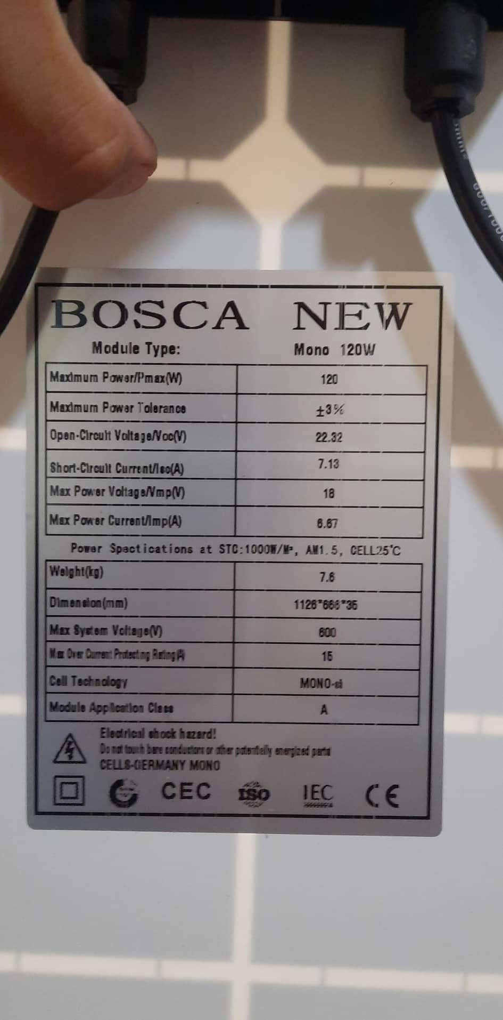

**Fig. 3 Model and specification of the Solar panel for the system**

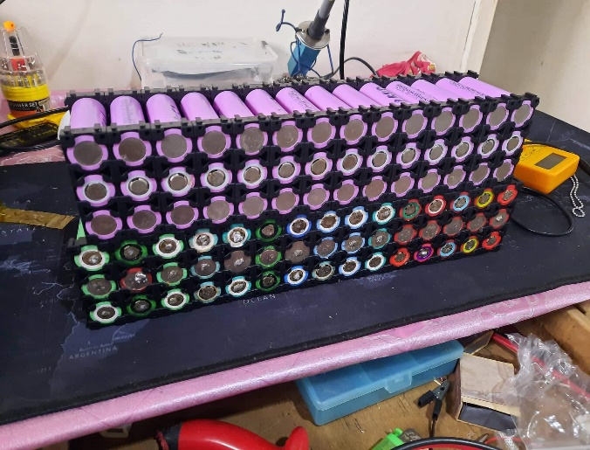

**Fig. 4 18650 lithium-ion batteries used for the battery system**

In terms of safety, The Researchers used a variety of multiple electric fuse to prevent possible damages to the infrastructure when a short-circuit happens within the system.

Table 1 shows the connection and the electrical fuse used by the researchers.

**Table 1 The connection and Electrical fuse used in the system**

|  |  |  |
| --- | --- | --- |
| Connection | Max Voltage | Fuse Amps |
| Solar Panel – Solar charge controller | 21 volts | 10amps |
| Solar Charge Controller – Battery | 12.7 volts | 20 amps |
| Battery - loads | 12.7 volts | 30 amps |

To ensure that the wires would not overheat and create a fire hazards, the research ensure that every wire used in the system can handle the amperes and voltage passing through. Table 2 show the tabulated assigned AWG for every wires used in the system.

**Table 2 shows the AWG of every wires used in the system.**

|  |  |  |  |  |
| --- | --- | --- | --- | --- |
| Connection | Distance | Max Voltage | Max Amps | AWG |
| Solar panel – Solar charge controller | 10 meters | 18.5 volts | 18.5 amps | 10 AWG |
| Solar Charge Controller - Battery | 1 meter | 12.6 volts | 9.52 amps | 14 AWG |
| Battery – Inverter | 1 meter | 12.6 volts | 40 amps | 10 AWG |
| Raspberry – buttons | 1 meter | 3.3 volts | 0.6 amps | 22 AWG |
| LED indicator | 1 meter | 12.6v | 1 amp | 22 AWG |

Furthermore, the researchers created a Mobile Application that will let the administrator control the system, users will have to login using the credentials first in order to access the application.

Moreover, the researchers created a Representational State Transfer (REST) API that will be consumed by both the created Web Application and the Raspberry Pi to access and modify information in the database. Figure 5 shows how the REST API connected to both the mobile application and Raspberry Pi for manipulating the database

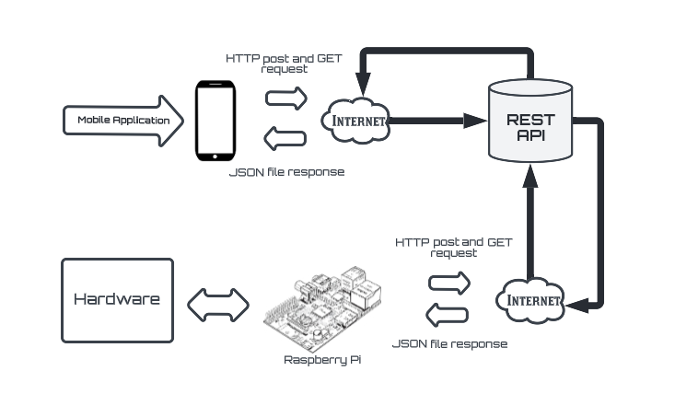

**Fig. 5 REST API connections for both the Mobile Application and**

**Raspberry Pi**

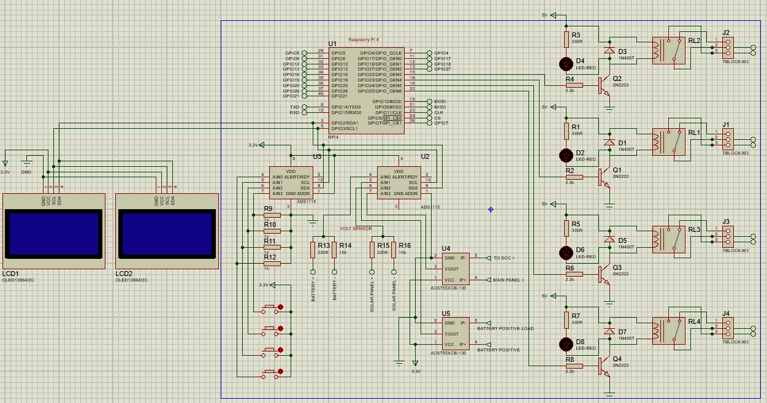

**Fig.6 Schematic Diagram of the Raspberry Pi and the components**

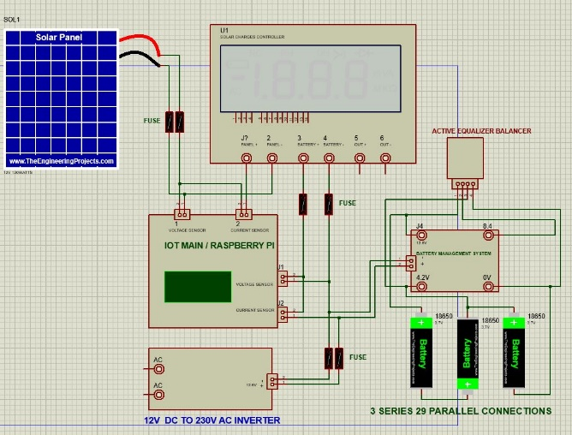  
**Fig. 7 Emergency Power supply powered by Solar Energy**

### B. Do

During the development, the researchers used the following technologies to develop all functionalities and features present in the Solar Energy Powered Emergency Power Supply with IOT based Monitoring and Controller Mobile App; both hardware and software:

1. **Python with Thonny IDE,** used for coding all control on the hardware system to the mobile app.
2. **PHP** is used on building the web view for the system with a help of **Bootstrap** to make in responsible UI,
3. **Awardspace** is used as the main hosting for our system the will handle the database.

The researchers used Python language in the Raspberry Pi as the main development language for every part present in the hardware such as current sensor, voltage sensor and OLED displays.

Li-ion batteries**,** also called as 18650 batteries is primarily used to store the energy gathered by the solar panels. To gather energy, the researchers used a single 12 volts 120 watts’ Solar panel and a PWM Solar charge controller to build the Solar powered power supply part of the system.

In the mobile web application, Bootstrap, PHP is used for building its UI as it is easier to maintain and use. Online hosting is being use as the database for the system where the raspberry pie will send the data from the system and use that database to display it to the mobile application. The REST API is built around PHP with Sequelize JSON to easily write SQL queries for accessing the MySQL database. Additionally, the mobile application is hosted in the internet via awardspace.com as well as the REST API. This makes the application accessible by anyone and anywhere around the web and also on mobile app. Figure 8 shows the main login page for the mobile application. Figure 9 shows the controller page of the mobile application.

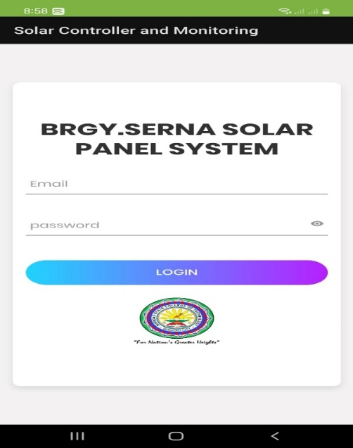

**Fig. 8 Login page of the mobile application**

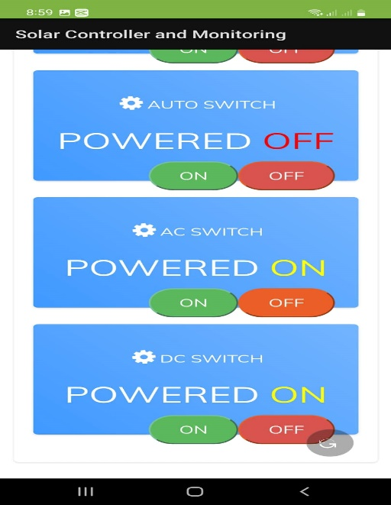

**Fig.9 Web-based Mobile Application Control Panel**

### C. Check

After identifying what pins are needed to be utilized for every hardware component based on the created schematic diagram, they are then prototyped on a universal PCB to see if every component is working properly before they are carefully connected to the Raspberry Pi. The deployed mobile application and REST API were also checked to see if they are all working the way on controlling the system, they are intended and is accessible in the APP by anyone. Figure 10 shows the entire setup of the system thoroughly connected. Figure 11 shows the main page of the mobile application for the system.

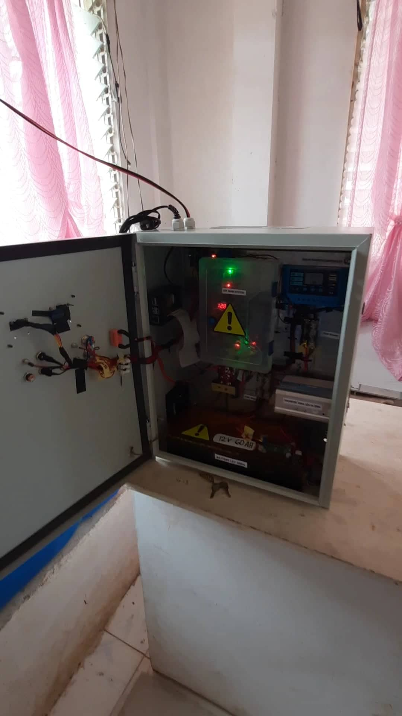

**Fig. 10** **Automated Emergency Power Supply Powered by Solar Energy with IOT-based Monitoring and Controller Mobile Application (Internal)**

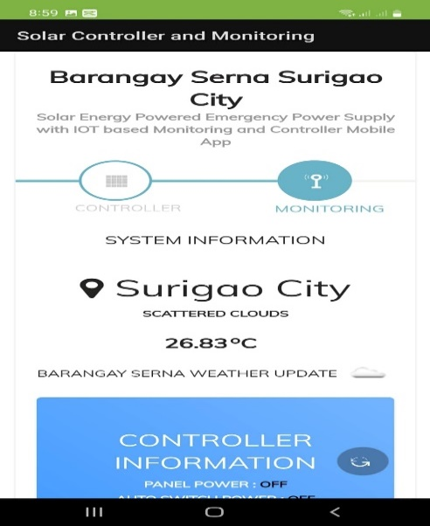

**Fig.11 Web-based Mobile Application Main Page**

### D. Act

***System Testing***

The researchers first tested the created REST API as it is the backbone of system as well as mobile application. All HTTP methods created are all tested to see if they are all working the way they are intended. Upon reaching a desirable result during the test, it is then connected first to the Mobile Application to check every functionality and controls if it is all working, and debugged the code when an error and vulnerability is recognized. Figure 12 shows the actual testing of the researchers to the mobile application using android mobile phone

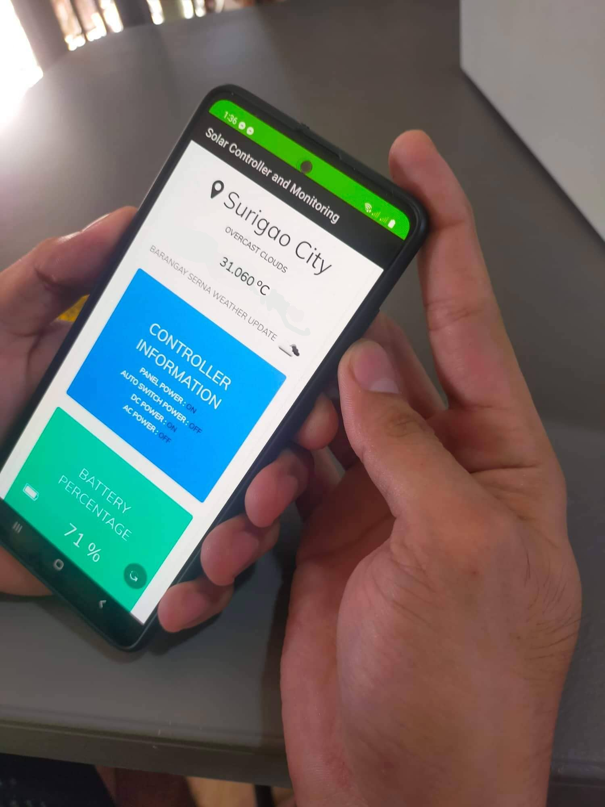

**Fig.12 Actual Testing of the mobile application on Android Mobile Phone**

The researchers then also tested the functionality of the control on the hardware via end-user’s interaction if it is working also and debugging all possible delays from control to function. The algorithm and codes of the functionality are progressively tweaked to reach a satisfying end-result. The researchers kept track of all functionality test results to easily debug and troubleshoot them if an error is recognized. Next, the mobile application is monitored by the researcher to track changes done in the codebase and easily maintain it as well as debugging all possible runtime errors. Figure 8 shows the 8 Automated Emergency Power Supply Powered by Solar Energy with IOT-based Monitoring and Controller Mobile Application (Internal)

Finally, the researchers tested the capability of the system in terms of the power it can provide while fully charge also how fast and efficient the charging rate of the system on the average amount of sunlight. The functionality is progressively tweaked to reach a satisfying end-result. Figure 13 shows the battery system setup of the system. Figure 14 and 15 shows the actual testing of the system on the target location.

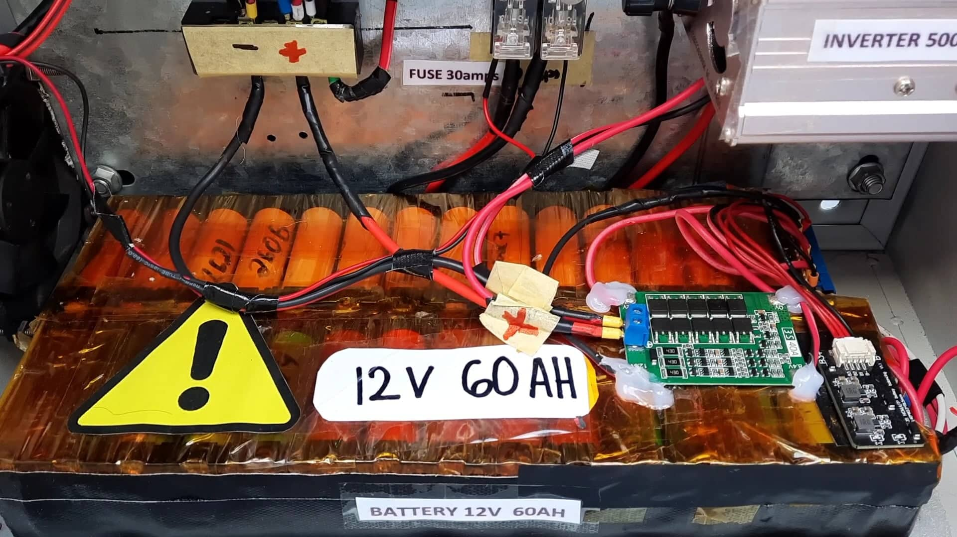

**Fig. 13 Main Battery system**

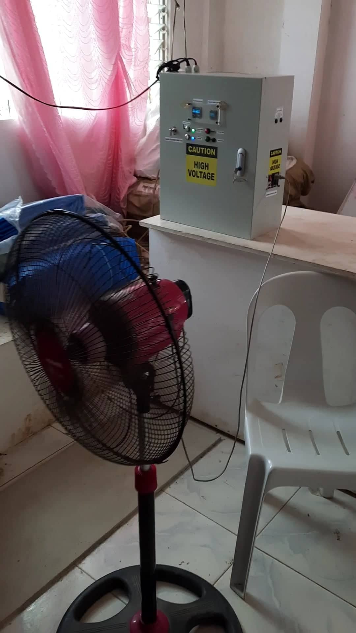

**Fig. 14 Actual testing of the system on the target location**

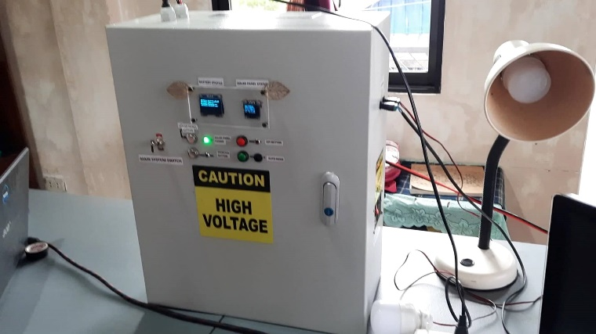

**Fig. 15 Actual testing of the system on the target location**

**III. RESULTS AND DISCUSSIONS**

This chapter discusses all results presented in the research methodology. It showcases all results related to the objectives of the study and the process of making the output.

**3.1 To determine the power request of Brgy. Serna’s Barangay hall.**

The researchers conducted an observation and research on the specific target, which is the Brgy. Serna’s Barangay Hall to get the average wattage of their daily usage of electricity so that the researchers would be able to supply the target with enough amount of electricity based on their need. The average wattage the Barangay hall daily usage goes up to 420 watts considering that they’re only using what is really needed to save electricity. Table 3 shows the wattage of the appliances mainly used by the Barangay hall.

**Table 3 Barangay Hall devices and their wattage**

|  |  |
| --- | --- |
| **Device** | **Wattage** |
| Electric Fan | 60 watts |
| Light Bulbs | 10 watts |
| Computer | 250 watts |
| Television | 200 watts |
| Mobile Charger | 15 watts/user |
| Laptop Charger | 60 watts/user |

The researcher then calculated the average wattage of the facility when they are using their most important devices and appliances to make sure that the system will have enough power supply for them. Table 4 shows the Barangay Hall average Daily Wattage

**Table 4 Barangay Hall average Daily Wattage**

|  |  |  |
| --- | --- | --- |
| **Day** | **Devices Connected** | **Average Wattage** |
| 1 | Computer  Electric Fan  Light Bulb | 330 watts |
| 2 | Light Bulb  Electric Fan  Laptop charger  Mobile charger | 145 watts |
| 3 | Computer  Electric Fan  Laptop charger  Mobile charger  Light bulb | 465 watts |

**3.2 To design and fabricate an emergency power supply powered by solar energy with IOT-based controlling and monitoring mobile application**

The researchers fully designed and fabricated a functional end-product that does all its features based on the first objective. Figure 6 shows the entire setup of the project, where the entire hardware is inside its metal junction box. Figure 7 shows the entire internal setup of the system.

The end-user will first make sure that the system is connected to the Wi-Fi connection so that the system can make the HTTP post and GET request to the API properly to send and receive data.

The end-user also has to make sure that the solar panels is getting enough sunlight so that the charging rate of the system is efficient and fast. The researchers were able to design and fabricate an Emergency power supply powered by Solar Energy. Figure 6 show the schematic diagram of the Emergency power supply.

The researcher fully designed and fabricated a web-based mobile application the can accessed anywhere when connected to the internet that can be used to monitor and control the system. Figure 8 shows the main page of the mobile application installed on Android mobile. Figure 9 shows the control panel of the mobile application where the system can be controlled by the buttons, current states of the button is also visible and present. Figure 10 shows the Monitoring page of the mobile application. To test the success rate of the HTTP post and get request of the mobile application, the researchers performed a simple test and tweaked the API endpoint until the it got the best result. Table 5 shows the record for the HTTP post and get request.

**Table 5 Web Server API Request Success Rate Test Results**

|  |  |  |  |  |
| --- | --- | --- | --- | --- |
| No. of Trials | (GET)  Fetch all command control | (POST) Add latest information | (POST) Add command control | Delay |
| 1 | 70% | 60% | 70% | 5sec |
| 2 | 90% | 80% | 90% | 6sec |
| 3 | 100% | 90% | 100% | 2sec |
| 4 | 100% | 100% | 100% | 1.5sec |
| 5 | 100% | 100% | 100% | 1.7sec |
| 6 | 100% | 100% | 100% | 1.2sec |
| 7 | 100% | 100% | 100% | 1.5sec |
| 8 | 100% | 100% | 100% | 1.5sec |
| 9 | 100% | 100% | 100% | 1.6sec |
| 10 | 100% | 100% | 100% | 1.7sec |

The end-user must first login to the Login page before they can be able to access the main function of the mobile application. Internet connection is a must because the mobile application won’t load if there is not internet connection present on the mobile phone.

**3.5 To test the efficiency of the charging and discharging rate of the power supply.**

The researcher performed another test to monitor the charging and the discharging of the power supply. Figure 12 show the main battery system for storing the power collected by the solar panel.

To fabricate the battery system, the researchers used lithium-ion batteries also called as 18650 batteries. Three 4.2v batteries are connected via series connection to have an output of 12.6DCV and the capacity is increased by using multiple parallel 12.6DCV series batteries. The capacity of the battery system is approximately 60,000 mAh and has the maximum discharge of 30amps. With our Battery system the life cycle of the 18650 cells can go from 300-500 charge cycles since our system only allows the 18650 cell to discharge at the minimum of 80% or the minimum of until 10.06 DCV. Table 6 shows the tabulated result of charging the battery system using 120 watts 12DCV solar panel.

**Table 6 Result of the charging test of the battery system using 12v 120 watts’ solar panel**

|  |  |  |  |
| --- | --- | --- | --- |
| **No. Day** | **Weather** | **Avg. Panel Amps** | **Time Before full charge** |
| 1 | Sunny | 8amps | 5hrs. & 33mins. |
| 2 | Cloudy | 6amps | 6hrs. & 40mins. |
| 3 | Sunny | 9amps | 5hrs. & 9mins. |
| 4 | raining | 5amps | 7hrs. & 2mins. |

To test the capacity of the battery system and how much power it can provide, the researcher performed a discharging test. Table 7 show the results of the discharging test of the battery system.

**Table 7 Results of the discharging test of the battery system using different levels of wattage**

|  |  |  |
| --- | --- | --- |
| No. of trials | Load  (wattage) | Duration until low power |
| 1 | 100 watts | 7 hrs. |
| 2 | 400 watts | 1 hrs. & 45 mins |
| 3 | 100 watts | 6 hrs. & 50 mins |
| 4 | 200 watts | 3 hrs. & 40 mins. |
| 5 | 50 watts | 15 hrs. |

The researchers then tested the system to Brgy. Serna’s Barangay Hall to ensure that the system can provide enough power for their common task. Using only the important and useful devices, the researcher performed a simple test to evaluate how long can the sytem provide electricity to the facility. Table 8 shows the tabulated result for the duration test of the system using the most important and useful device on the target location.

**Table 8 Results of the duration test of the system to the target location**

|  |  |  |  |
| --- | --- | --- | --- |
| No. of Test | Devices Connected | Total Wattage | Duration before Low-Battery |
| 1 | Light Bulb  Computer | 290 watts | 3 hrs |
| 2 | Light Bulb  Electric Fan | 90 watts | 7 hrs & 30 mins |
| 3 | Light Bulb  Electric Fan  Computer  Mobile Charging  Laptop Charging | 400 watts | 1 hr. & 30 mins |

**3.6 To implement the system to the Barangay Hall of Brgy. Serna, Surigao City.**

The researchers implemented the Automated Emergency Power Supply Using Solar Energy with IOT-based Monitoring and Controller Mobile Application to the barangay hall of Brgy. Serna with the help of Bgry. Captain Mr. Ravello and his subordinates. Figure 16 shows the output of the monitoring of the final system being implemented on Brgy. Serna Barangay Hall.

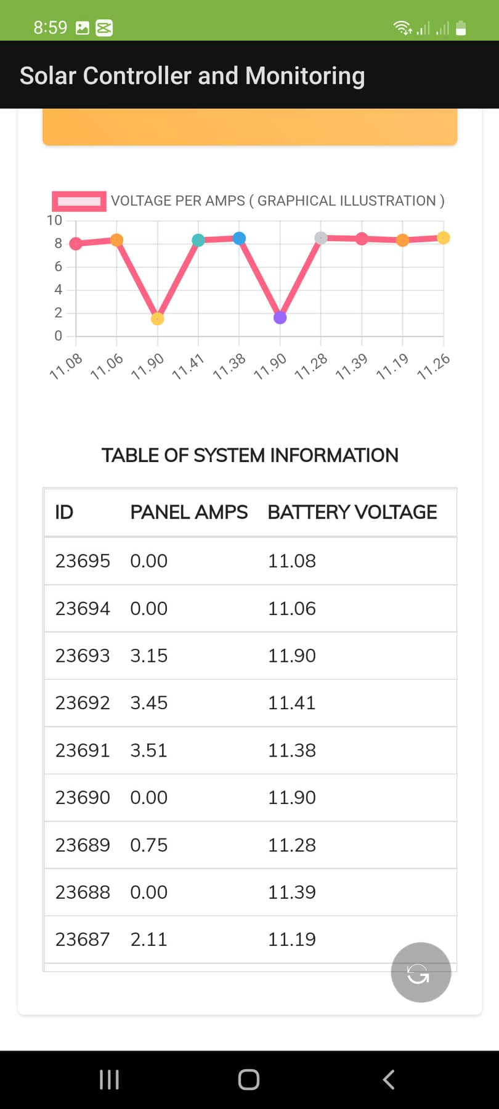

**Fig.16 Web-based Mobile Application Monitoring and Daily Record of the system**

**IV. CONCLUSION AND RECOMMENDATION**

### After a series of multiple and thorough testing processes conducted by the researchers, the fabrication and development of the Automated Emergency Power Supply Using Solar Energy with IOT-based Monitoring and Controller Mobile Application were found and proved to work effectively and functionally with good maintainability as hardware parts are available locally.

### Conclusions

### The researchers were able to design and fabricate an Emergency power supply using raspberry pi with IOT based mobile application for management, controls and monitoring of the system. When operating the system via physical buttons, every button pressed is recorded and sent to the REST API so that the mobile application can compare the controls signal on based on the database so it can be displayed on the app and when operating the system on the mobile application, the application will send all the command signals on the REST API while the raspberry pi reads the database so it could perform the controls signals. The development of REST API for communicating with the database also proved to be beneficial as it lets other application in different platform access the database as long as they have the correct credentials for using it.

Furthermore, the use of a Raspberry Pi 4B as the main microcomputer of the project played a huge role in the accuracy and entire processing speed of the entire system especially on the HTTP Post and GET request. The interconnection is also an important factor because the mobile application cannot be able to control the system if the system is not connected to the internet.

The functionalities of the IOT-based monitoring and controller app of emergency power supply powered by solar energy were all met and is functioning correctly, due to this, it is planned to be installed and implemented in Brgy. Serna, Surigao City.

### Recommendations

Since the developed project has limitations, the researchers recommend to the future researchers to redesign the system to be more flexible in terms of the following aspects:

1. The ability to send SMS to the user when a power outage is detected by the systems.

2. The ability to read the temperature of system

3. Use a better or upgrade the hosting provider for both the Frontend Web Application and the REST API instead of using a free tier plan.

4. Upgrade the capacity of the batteries and increase the wattage of the solar panel for higher capacity and faster charging rate.

**V. ACKNOWLEDGMENTS**

The researchers would like to acknowledge and express their sincere and utmost gratitude to all who helped convert this a study into reality. First and foremost, to God Almighty for His unending love and for guiding the researchers through all their difficulties. To J. I. Teleron for being understanding and responsive to queries anytime and for sharing his valuable knowledge and guiding them throughout this development. Finally, to the researchers' loving and ever caring parents for supporting financially, emotionally, and spiritually. They were constantly there, assisting them in all their struggles and times of distress.

**VI. REFERENCE**

[1] Adejuyigbe, S. B., Bolaji, B. O., Olanipekun, M. U., & Adu, M. R. (2013). Development of a solar photovoltaic power system to generate electricity for office appliances. Engineering Journal, 17(1), 29–39. https://doi.org/10.4186/EJ.2013.17.1.29

[2] Gopal, M., Chandra Prakash, T., Venkata Ramakrishna, N., & Yadav, B. P. (2020). IoT Based Solar Power Monitoring System. IOP Conference Series: Materials Science and Engineering, 981(3). https://doi.org/10.1088/1757-899X/981/3/032037

[3] Wang, L., Zhu, M., Chen, P., Deng, C., Liu, Z., & Wang, Y. (2016). Study of emergency power based on solar battery charging. MATEC Web of Conferences, 61. https://doi.org/10.1051/MATECCONF/20166102025

[4] N. H. Ramly, Noor Zaihah Jamal, Abdul Nasir Abd Ghafar and Devin Babu (2016), Emergency Portable Solar Power Supply, International Journal of Engineering Technology and Sciences (ijets), DOI: http://dx.doi.org/10.15282/ijets.6.2.2019.1007

[5] Rawandale, U. S., Katyarmal, M., Arvind, S. & Walkunde, S. (2018). Solar Power Monitoring system using IoT’. IJIRCCE, International Journal of Innovative Research in Computer and Communication Engineering, 5.0(Issue in e-ISSN:2395-0056,p-ISSN:2395-0072, www.irjet.net.):2395.0–72.0.

[6] Kekre, A., & Gawre, S. K. (2018). Solar photovoltaic remote monitoring system using IOT. International Conference on Recent Innovations in Signal Processing and Embedded Systems, RISE 2017, 2018-January, 619–623. https://doi.org/10.1109/RISE.2017.8378227

[7] Eteruddin, H., Setiawan, D., & Atmam, A. (2020). Web Based Raspberry Monitoring System Solar Energy Power Plant. IOP Conference Series: Earth and Environmental Science, 469(1), 012051. https://doi.org/10.1088/1755-1315/469/1/012051

[8] Datar, N., Bhoyar, S., Khan, A., Dekapurwar, S., Wankhede, H., Sonone, S., Bapat, V., & Dhote, N. K. (2021). Solar Power Monitoring System Using IOT. Journal of Emerging Trends in Electrical Engineering, 3(1). http://hbrppublication.com/OJS/index.php/JETEE/article/view/1878

[9] Rajeshwar Reddy, K., Arabelli, R. R., Rajababu, D., & Mahender, K. (2020). Solar power generation system with IOT based monitoring and controlling using different sensors and protection devices to continuous power supply. IOP Conference Series: Materials Science and Engineering, 981(3), 032017. https://doi.org/10.1088/1757-899X/981/3/032017

[10] Deshmukh, N. S., & Bhuyar, D. L. (2019). A Smart Solar Photovoltaic Remote Monitoring and Controlling. Proceedings of the 2nd International Conference on Intelligent Computing and Control Systems, ICICCS 2018, 67–71. https://doi.org/10.1109/ICCONS.2018.8663127

[11] Oukennou, A., Berrar, A., Belbhar, I., Hamri, N. el, El, N., Low Cost, H., & Uk, A. (2019). Low Cost IoT System for Solar Panel Power Monitoring CORE View metadata, citation and similar papers at core Low Cost IoT System for Solar Panel Power Monitoring. https://hal.archives-ouvertes.fr/hal-02298769

[12] Ghuge, Dr. N. N., Vishal, D., Kunal, B., & Kulkarni, M. (2021). IoT Based Battery Management System for Electric Vehicles. SSRN Electronic Journal. https://doi.org/10.2139/SSRN.3917899

[13] Bhau, G. V., Deshmukh, R. G., kumar, T. R., Chowdhury, S., Sesharao, Y., & Abilmazhinov, Y. (2021). IoT based solar energy monitoring system. Materials Today: Proceedings. https://doi.org/10.1016/J.MATPR.2021.07.364

[14] Ramani, U., Kumar, S. S., Santhoshkumar, T., & Thilagaraj, M. (2019). IoT Based Energy Management for Smart Home. Proceedings of the 2019 2nd International Conference on Power and Embedded Drive Control, ICPEDC 2019, 533–536. https://doi.org/10.1109/ICPEDC47771.2019.9036546

[15] Patil, S., Vijayalashmi, M., & Tapaskar, R. (2017). SOLAR ENERGY MONITORING SYSTEM USING IoT. Indian Journal of Scientific Research, 149–156. https://go.gale.com/ps/i.do?p=AONE&sw=w&issn=09762876&v=2.1&it=r&id=GALE%7CA521163122&sid=googleScholar&linkaccess=fulltext

[16] Priharti, W., Rosmawati, A. F. K., & Wibawa, I. P. D. (2019). IoT based photovoltaic monitoring system application. Journal of Physics: Conference Series, 1367(1), 012069. https://doi.org/10.1088/1742-6596/1367/1/012069

[17] Syu, J. H., Wu, M. E., Srivastava, G., Chao, C. F., & Lin, J. C. W. (2021). An IoT-Based Hedge System for Solar Power Generation. IEEE Internet of Things Journal, 8(13), 10347–10355. https://doi.org/10.1109/JIOT.2021.3064384

[18] Kumar, M., Minai, A. F., Khan, A. A., & Kumar, S. (2020). IoT based Energy Management System for Smart Grid. Proceedings - 2020 International Conference on Advances in Computing, Communication and Materials, ICACCM 2020, 2020-January, 121–125. https://doi.org/10.1109/ICACCM50413.2020.9213061

[19] M. A. Rahman, M. Y. Mukta, A. Yousuf, A. T. Asyhari, M. Z. A. Bhuiyan and C. Y. Yaakub, "IoT Based Hybrid Green Energy Driven Highway Lighting System," 2019 IEEE Intl Conf on Dependable, Autonomic and Secure Computing, Intl Conf on Pervasive Intelligence and Computing, Intl Conf on Cloud and Big Data Computing, Intl Conf on Cyber Science and Technology Congress (DASC/PiCom/CBDCom/CyberSciTech), 2019, pp. 587-594, doi:10.1109/DASC/PiCom/CBDCom/CyberSciTech.

2019.00114

[20] A, R., R, B., R, D. K., P, E. B., & N, G. P. (2022). IoT based Solar Energy Monitoring and Fault Detection. 442–446. https://doi.org/10.1109/ICICCS53718.2022.9788278

[21] Anguraj, D. K., Balasubramaniyan, S., Saravana Kumar, E., Vakula Rani, J., & Ashwin, M. (2022). Internet of things (IoT)-based unmanned intelligent street light using renewable energy. International Journal of Intelligent Unmanned Systems, 10(1), 34–47. https://doi.org/10.1108/IJIUS-10-2020-0060/FULL/XML

[22] Hans, M. R., & Tamhane, M. A. (2020). IoT based hybrid green energy driven street lighting system. Proceedings of the 4th International Conference on IoT in Social, Mobile, Analytics and Cloud, ISMAC 2020, 35–41. https://doi.org/10.1109/I-SMAC49090.2020.9243365

1. Joshi, Megha A., and S. Kavyashree. "IOT Based Smart Inverter Using Raspberry PI." International Journal of Latest Technology in Engineering, Management & Applied Science (2017). https://bit.ly/3wmZdiv
2. Adhya, Soham, et al. "An IoT based smart solar photovoltaic remote monitoring and control unit." 2016 2nd international conference on control, instrumentation, energy & communication (CIEC). IEEE, 2016. https://ieeexplore.ieee.org/abstract/document/7513793
3. Primiceri, Patrizio, and Paolo Visconti. "Solar-powered LED-based lighting facilities: an overview on recent technologies and embedded IoT devices to obtain wireless control, energy savings and quick maintenance." Journal of Engineering and Applied Sciences ARPN 12.1 (2017): 140-150. https://bit.ly/3wmsdfe

[26] (PDF) Solar Power as Renewable Energy for Home Systems in Bangladesh. (n.d.). Retrieved August 24, 2022, https://bit.ly/3wmZdiv22

[27] Shiau, J. K., & Ma, C. W. (2013). Li-Ion battery charging with a buck-boost power converter for a solar powered battery management system. Energies, 6(3), 1669–1699. https://doi.org/10.3390/EN6031669

[28] Patchava, V., Kandala, H. B., & Babu, P. R. (2017). A Smart Home Automation technique with Raspberry Pi using IoT. 2015 International Conference on Smart Sensors and Systems, IC-SSS 2015. https://doi.org/10.1109/SMARTSENS.2015.7873584